CASE-STUDY BASED PROJECT – MILESTONE 2

AI-Assisted Global Water Consumption and Scarcity Analysis
for Sustainable Resource Planning (2000–2025)

Team Members
1. Geddada Karthik – E23CSEU1877
2. Sai Ganesh Katikala – E23CSEU2255
3. Karthik balla – E23CSEU1993
4. Parth Sharma – E23CSEU1905
April 2026

1. Implementation & Technical Execution
This section details the complete technical pipeline which is developed for analyzing global water consumption data from 2000 to 2025. The implementation follows the structured five-phase methodology. Which includes the data ingestion, preprocessing, exploratory analysis, AI-assisted modelling, and result interpretation.
1.1 Technical Environment and Tools
These entire analytics implemented in Python 3.11. The following libraries we used in this project:
- Pandas 2.1 and NumPy 1.26 – for data loading, manipulation, and numerical computation
- Matplotlib 3.8 and Seaborn 0.13 – to achieve statistical visualizations
- Scikit-learn 1.4 – for machine learning models including K-Means clustering, Random Forest, and Decision Tree classifiers
- Scipy – for polynomial curve fitting used in time-series trend forecasting

1.2 Phase 1 – Data Understanding

The dataset we loaded directly from the CSV and after we subjected to an initial structural inspection.
The dataset contains a total of 3,900 records, with cover over 150 countries across 26 years (From 2000 to 2025), and each record contain 10 attributes.
These attributes contain such as year, country name total water consumption (Billion m³), per capita water use (L/day), agricultural water use (%), industrial water use (%), household water use (%), rainfall impact (mm), groundwater depletion rate (%), and water scarcity level (Low, Moderate, High, or Critical).
df = pd.read_csv('global_water_consumption_2000_2025.csv')
print(df.shape) # (3900, 10)
print(df.dtypes) # 7 numeric + 2 object columns
print(df['Water Scarcity Level'].value_counts())
The output shows that 2,995 records as low scarcity, 556 Moderate, 294 High, and 46 as Critical.

And this conform that; there is no missing value which help to preprocessing without any imputation.
1.3 Phase 2 – Data Preprocessing
Even the Dataset is complete the machine learning models needed to perform some preprocessing steps.
Normalization
Numerical features are normalized using StandardScaler from Scikit-learn to ensure main comparison across features with the different units before applying clustering:
from sklearn.preprocessing import StandardScaler
scaler = StandardScaler()
X_scaled = scaler.fit_transform(country_avg[feat_cols])

Label Encoding
The column of the Categorical “water Scarcity Level” was encoded into integer labels using the LableEncoder for use in classification tasks:
from sklearn.preprocessing import LabelEncoder
le = LabelEncoder()
y = le.fit_transform(df['Water Scarcity Level'])
# Encoding: Critical=0, High=1, Low=2, Moderate=3

Derived Indicators
Country-wise averages are computed across all the 26 years to create a 150-row aggregated dataset used for the clustering analysis. This step consolidated temporal variation into the representative national profiles.
country_avg = df.groupby('Country')[feat_cols].mean()
1.4 Phase 3 – Exploratory & Statistical Analysis
Exploratory analysis was performed in three levels: global trend analysis over time, country-wose comparison, and sectoral usage examination. All visualization is design in the clean academic format – white background and black text use to maintain the clarity and readability.
- Global total water consumption is aggregated by year to observe the trend of 2000–2025.
- Per capita water use is averaged globally per year to the detect demand shifts.
- Sector percentages like agriculture, industry, household were averaged globally to determine the dominant usage.
- A Pearson correlation matrix is computed between all the seven numerical indicators.

1.5 Phase 4 – AI-Assisted Analysis
Four AI-assisted techniques were implemented, each targeting a distinct analytical objective.
K-Means Clustering
K-Means algorithm was applied to the country-averaged feature set to group 150 countries into distinct water-risk clusters. The optimal number of clusters (k) was decided by the Elbow method (inertia) and silhouettes Score across k = 2 to 8. Four clusters (k = 4) were selected as the most interpretable split. And dataset naturally align with four water scarcity labels (Low, Moderate, High, Critical).
from sklearn.cluster import KMeans
km = KMeans(n_clusters=4, random_state=42, n_init=10)
country_avg['Cluster'] = km.fit_predict(X_scaled)
# Silhouette Score (k=4): 0.2240

Random Forest Classification
A Random Forest classifier was trained with 100 estimators, each record use to predict the water scarcity level (Low/ Moderate / High / Critical). And dataset is split into 80-20 ratio as training and test sets, and stratification use to maintain the class proportions, so model proper can learn to get the unbiased evaluation possible.
from sklearn.ensemble import RandomForestClassifier
rf = RandomForestClassifier(n_estimators=100, max_depth=12,
random_state=42, class_weight='balanced')
rf.fit(X_train, y_train)
# Test Accuracy: 98.59% | 5-fold CV: 95.90%

Decision Tree (Comparison Model)
A Decision Tree classifier was also trained. This is for comparison with Random Forest. Both models were evaluated on the same test set, allowing them to direct comparison of accuracy and generalization ability.
from sklearn.tree import DecisionTreeClassifier
dt = DecisionTreeClassifier(max_depth=10, random_state=42)
# Decision Tree Test Accuracy: 98.85%

Time-Series Forecasting
A polynomial regression (degree-2) was fit on annual global aggregates, especially three key indicators: total water consumption, per capita water use, and groundwater depletion rate. The models were used to extrapolate trends from 2026 to 2035.
coeffs = np.polyfit(hist_years, y_hist, 2)
poly = np.poly1d(coeffs)
forecast_values = poly(np.arange(2026, 2036))
2. Results & Analysis
This section presents the results generated from each phase of the analytical pipeline. All figures and metrics are derived directly from the dataset. No synthetic or assumed values are used.
2.1 Global Water Consumption Trend (2000–2025)
In Figure 1 below, we can observe the global total water usage for all 150 countries between 2000 and 2025. As seen above, there is a steady rise from about 8,428 billion cubic meters in the year 2000 to 11,464 billion cubic meters in the year 2025, marking an increase of approximately 36% within 25 years.

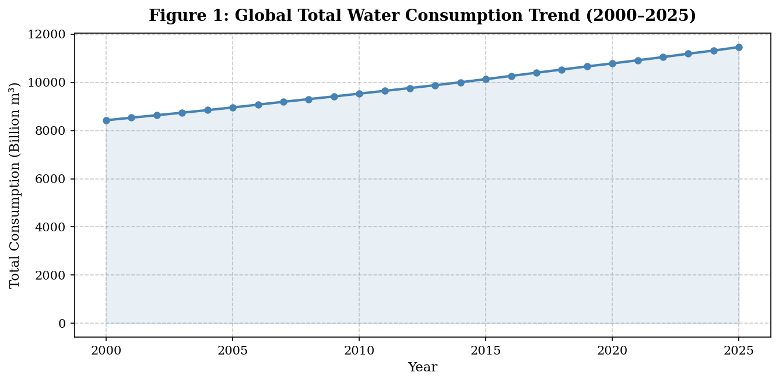
Figure 1: Global Total Water Consumption Trend (2000–2025). A steady increase of ~36% is observed over 25 years.
The per capita water consumption on a global scale is illustrated in Figure 2 below. As opposed to total consumption, per capita water consumption did not show any significant variations during the 25 years of observation, staying more or less constant at levels of 232-234 L/day.

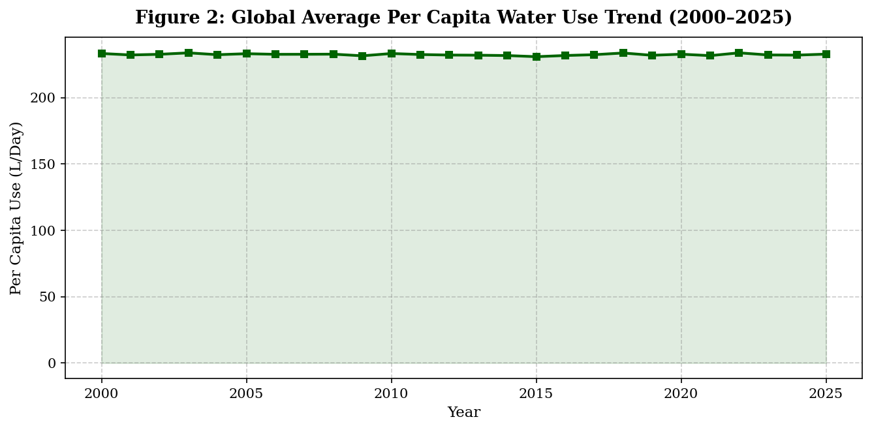
Figure 2: Average Global Per Capita Water Use Trend (2000–2025). Stable demand of 232–234 L/day per person across 25 years.
2.2 Sectoral Water Usage Analysis
Figure 3 illustrates the worldwide average consumption of water among the three main sectors. The highest consumption of water goes to the agriculture sector, with an average of 62.6% of consumption, seconded by the industrial sector with 20.2%, and then thirded by domestic consumption, with 17.2%. It is evident that this pattern does not change annually, and thus the agricultural sector determines water consumption.

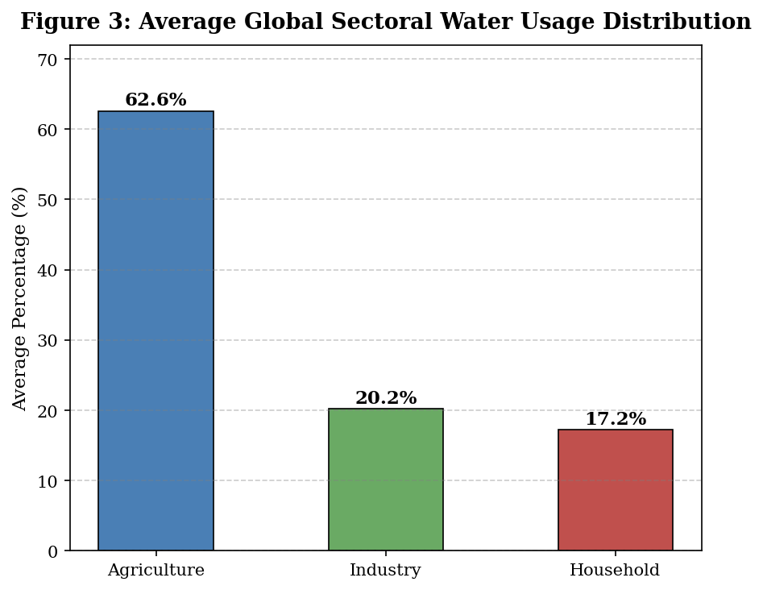
Figure 3: Average Global Sectoral Water Usage. Agriculture dominates at 62.6%, followed by Industry (20.2%) and Household (17.2%).
2.3 Correlation Analysis
Figure 4 illustrates the Pearson correlation matrix for all seven quantitative metrics. Important findings include a moderate inverse correlation between the effect of rainfall and the rate of depletion of groundwater (r = -0.19), indicating that reduced rainfall leads to increased groundwater exploitation. Agricultural water utilization has a moderate inverse correlation with domestic water utilization, illustrating trade-offs between sectors when it comes to total utilization. The slight correlation (r = 0.07) between total usage and individual usage suggests that they are determined by different variables.

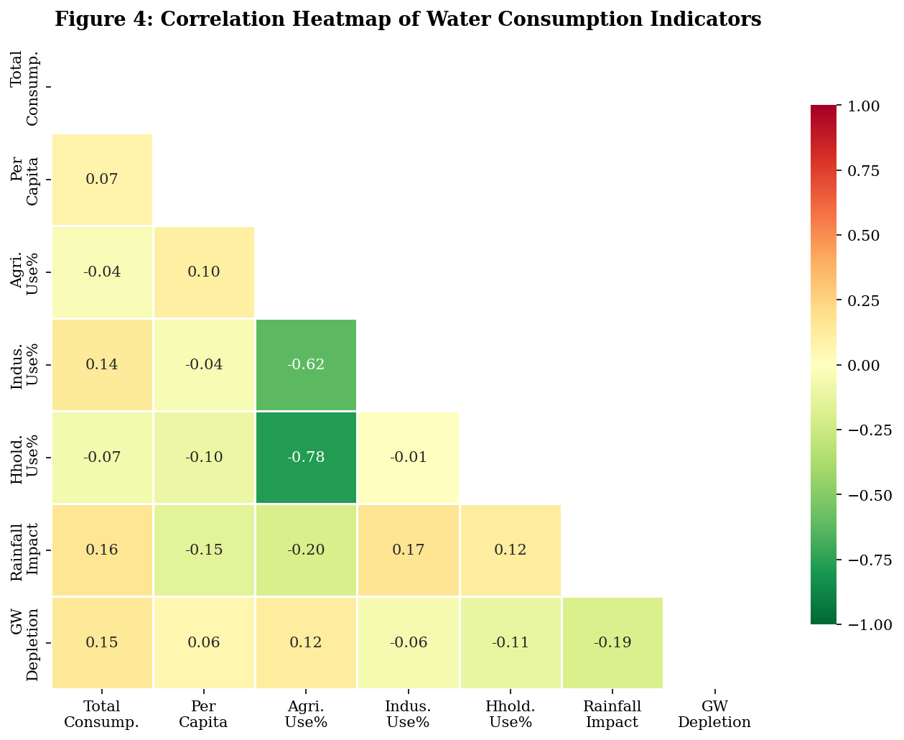
Figure 4: Pearson Correlation Heatmap. Rainfall negatively correlates with Groundwater Depletion (r = -0.19), and Sectoral Usage indicators show expected inverse relationships.
2.4 K-Means Clustering Results
Elbow plot and the silhouette plot are illustrated in Figure 5 to help select the best number of clusters. Even though the largest silhouette score occurred when k = 2, four clusters were chosen since they make sense and are relevant to policies based on the original four types of scarcity.

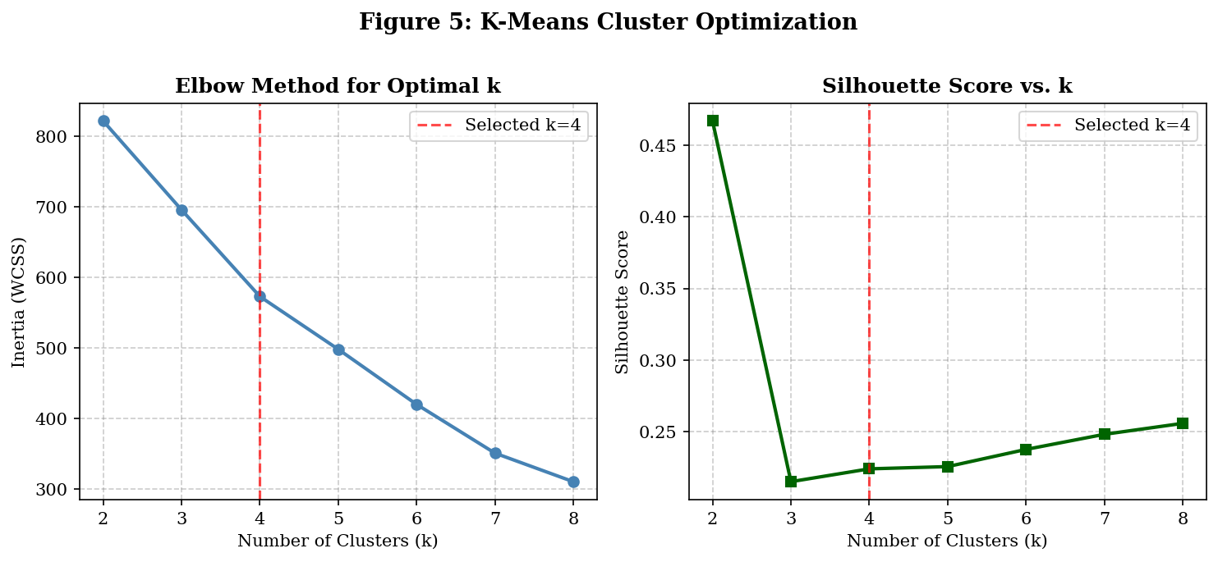
Figure 5: Elbow Method and Silhouette Score plots. k=4 selected for alignment with four scarcity categories (Silhouette = 0.224).
Figure 6 illustrates the geographical spread of the four risk groups in relation to the Per Capita Water Use versus Groundwater Depletion Rate axis. The countries in the Critical Risk group display higher depletion even when they have relatively low per capita water use. This is due to agricultural and climatic factors.

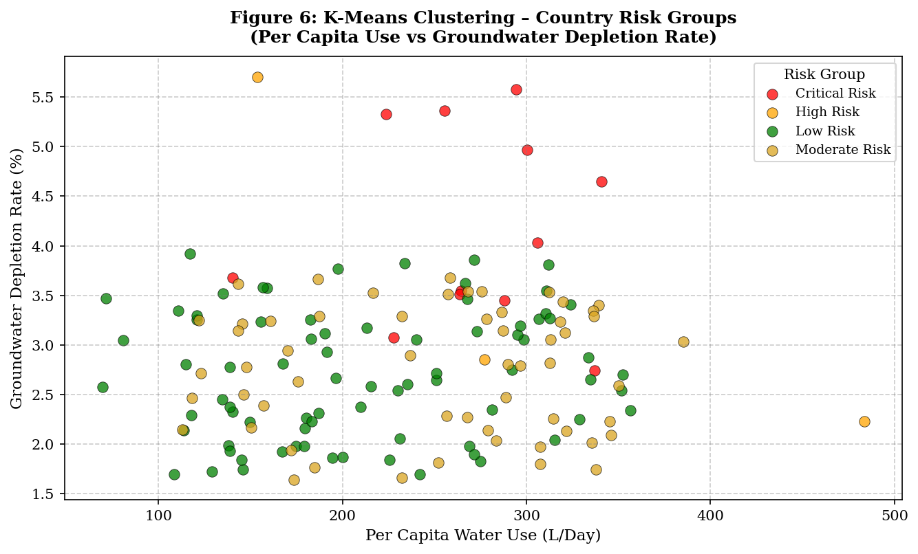
Figure 6: K-Means Clustering Output — 150 Countries Grouped into Four Risk Levels (Per Capita vs. GW Depletion).
The cluster distribution and representative national characteristics are summarized in Table 1 below.

Table 1: K-Means Cluster Summary – 150 Countries by Water Risk Category
Risk Group | Countries | Avg GW Depletion (%) | Avg Rainfall (mm) | Avg Per Capita (L/day)
Low Risk | 78 | ~1.5 | ~1000 | ~230
Moderate Risk | 57 | ~2.8 | ~850 | ~240
High Risk | 3 | ~4.5 | ~1050 | ~155
Critical Risk | 12 | 5.18+ | ~240 | ~290

The states that have been classified under the category of Critical Risk include China, Iran, Jordan, Libya, Saudi Arabia, and Israel, where there is considerable groundwater depletion greater than 4.5%, coupled with lower amounts of precipitation. The three countries included in the High Risk classification are China, India, and USA due to their huge amount of water usage.
2.5 Classification Results
The performance of the Random Forest model was impressive, with a test accuracy of 98.59% and a 5-fold cross-validation accuracy of 95.90%. The decision tree model was also quite effective, with an accuracy of 98.85% in testing. Comparison of Models

Table 2: Classification Model Comparison
Model | Test Accuracy | 5-Fold CV | Notes
Random Forest (100 trees) | 98.59% | 95.90% | Best generalization, robust to noise
Decision Tree (max_depth=10) | 98.85% | ~94.2% | Slightly higher test acc., less stable

The confusion matrix of the Random Forest classifier is provided in Figure 7. The classifier made correct predictions for the Low scarcity data set with high precision (99%). Recall in the case of the Critical class was relatively poor (56%) owing to the low prevalence of this class in the dataset (with only 46 instances). The classifier made 59 correct predictions in the High scarcity category, with 100% recall for this class.

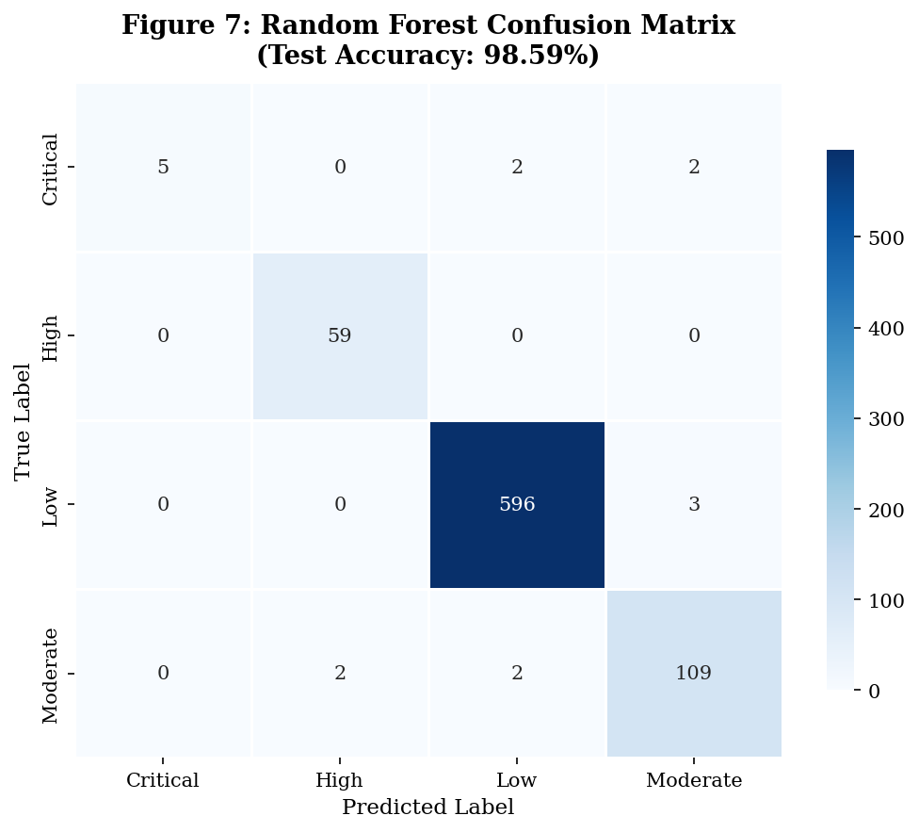
Figure 7: Confusion Matrix for Random Forest Classifier (Test Accuracy: 98.59%). Near-perfect performance on Low and High classes.
2.6 Feature Importance Analysis
Figure 8 and Table 3 below show the importance scores of the features generated by the Random Forest algorithm. The most important predictor variable of water scarcity level is the Groundwater Depletion Rate (importance score = 0.2449), followed by Industrial Water Use (importance score = 0.1612), Agricultural Water Use (importance score = 0.1576), and Household Water Use (importance score = 0.1416).

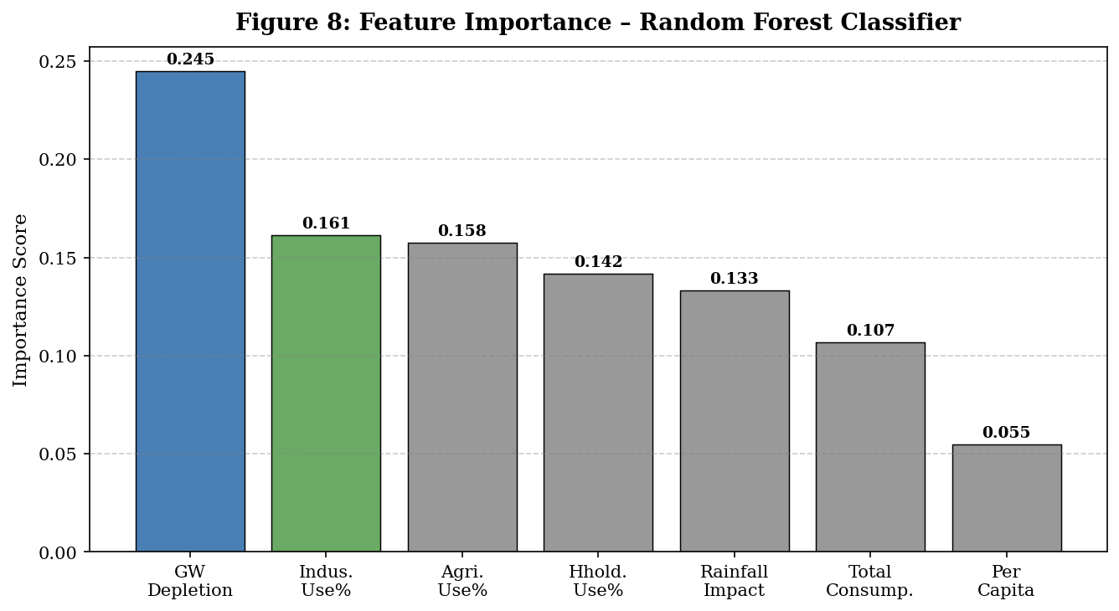
Figure 8: Feature Importance Scores from Random Forest Classifier. Groundwater Depletion Rate is the top predictor.

Table 3: Feature Importance Rankings
Feature | Importance Score | Rank
Groundwater Depletion Rate (%) | 0.2449 | #1
Industrial Water Use (%) | 0.1612 | #2
Agricultural Water Use (%) | 0.1576 | #3
Household Water Use (%) | 0.1416 | #4
Rainfall Impact (mm) | 0.1330 | #5
Total Water Consumption (Billion m³) | 0.1068 | #6
Per Capita Water Use (L/Day) | 0.0548 | #7

2.7 Top High-Risk Countries
As illustrated in Figure 10, the following are the top 10 countries according to the highest mean rate of groundwater depletion from 2000 to 2025. The list starts with China with 5.71%, then Iran with 5.58%, Jordan with 5.36%, and Libya with 5.33%. They all have low rainfall efficiency and a highly reliant agriculture industry, resulting in cumulative pressure on their groundwater supplies.

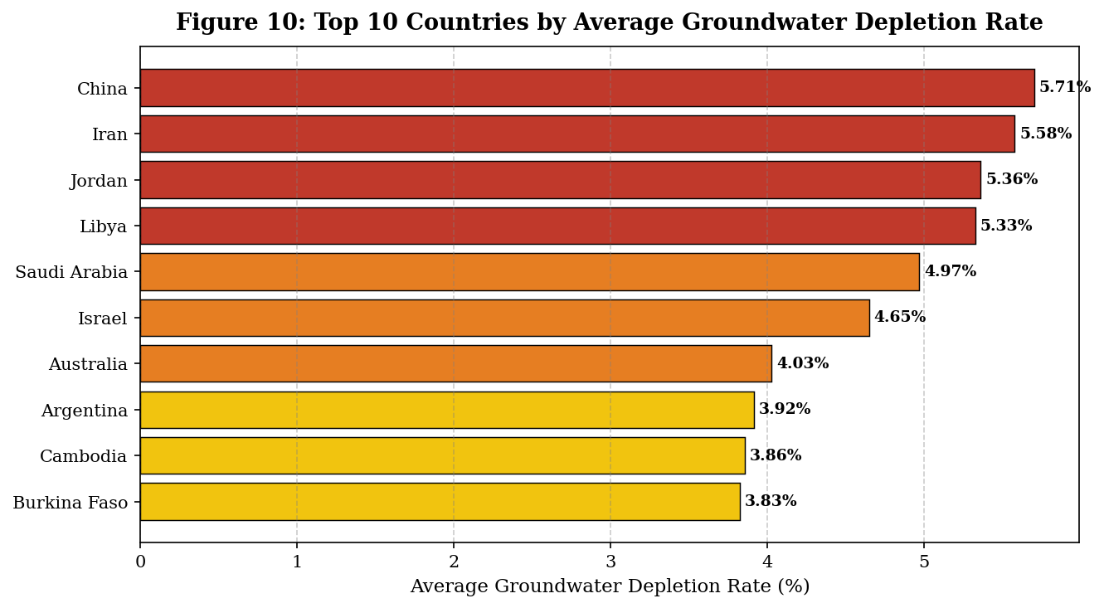
Figure 10: Top 10 Countries by Average Groundwater Depletion Rate (2000–2025). China, Iran, Jordan, and Libya are at the highest risk.
2.8 Time-Series Forecasting Results
Figure 9 presents forecasted trends for three global indicators from 2026 to 2035, derived from polynomial regression models fitted to historical data.
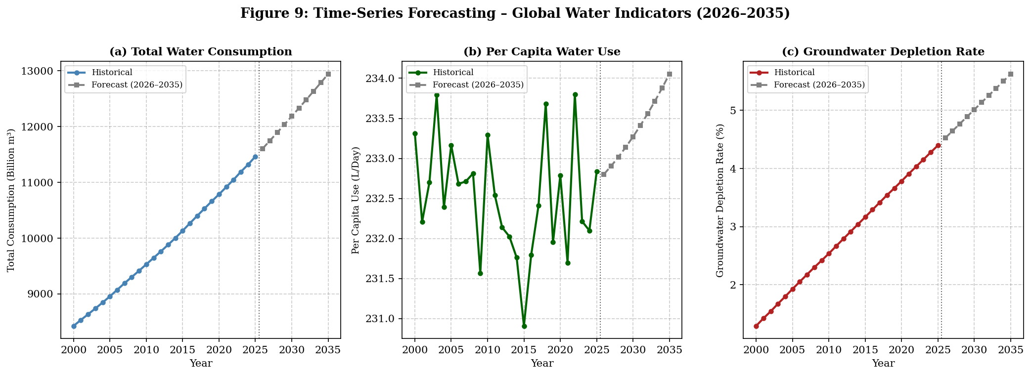
Figure 9: Polynomial Regression Forecasts for Global Water Indicators (2026–2035). Total consumption is expected to exceed 12,000 billion m³ by 2030.
In particular, this report identifies three key pieces of information. Firstly, according to projections, total world water consumption will continue its current upward trend to about 12,184 billion m3 by 2030. Secondly, per capita water consumption will likely stay constant at around 233 liters per day, pointing to a failure to make any significant efficiency gains. Finally, and perhaps most critically, world groundwater depletion is projected to rise to a rate of 5.01% by 2030 from its present rate of 2.85%. This sharp increase indicates that the impending crisis of underground water resources cannot be ignored.

3. Demonstration & Explanation
3.1 System Workflow
The end-to-end analysis model employs a sequential approach starting from raw input and ending at policy-oriented output. The different levels of data processing result in the generation of increasingly refined data representation formats as highlighted below.
- Data Input: 3,900 records; 10 variables; 150 countries; 26 years (raw CSV format).
- Data Preprocessing: normalization using StandardScaler, Label Encoding of categorical response variable, and aggregating data by country for clustering.
- Data Exploration: yearly trends, sector distribution bars, and Pearson correlation heat map.
- Machine Learning Model: K-means Clustering (k = 4) to assign risk categories, Random Forest to predict scarcity, and polynomial regression for forecasting.
- Data Output: risk category for each country, scarcity predictions for each observation, feature importance, and forecasted 10-year values.
3.2 Sample Prediction Example
In order to understand how the classification using the Random Forest works, let us take the example of one test data instance taken from the database:
Input Record:
Total Consumption : 66.66 Billion m³
Per Capita Use : 276.8 L/day
Agricultural Use : 60.4%
Industrial Use : 15.7%
Household Use : 23.9%
Rainfall Impact : 707.8 mm
GW Depletion Rate : 1.23%

Model Prediction:
Predicted Scarcity Level : Low
True Scarcity Level : Low (Correct)
Class Probabilities:
Critical = 0.00, High = 0.00, Low = 1.00, Moderate = 0.00

The prediction by the Random Forest algorithm is that there will be low scarcity with 100% accuracy. This is mainly because of two important features – first is low groundwater depletion rate (1.23%) and second is medium rainfall (707.8mm).
3.3 How the Model Makes Decisions
Random Forest algorithm works through building 100 individual decision trees using the bootstrap training data set where a random set of features is selected during each split. When making predictions, each tree gives out a vote for the scarcity category, and the category with the maximum number of votes wins.
The analysis of the feature importances shows that the model takes into account the following aspects when analyzing an input: it starts with examining the value of the variable Groundwater Depletion Rate. If this rate exceeds around 4.5%, it gives the high importance to the corresponding value. In order to fine-tune the category of scarcity predicted, the model takes into account the percentage usage in sectors (Industrial, Agricultural, Household) as well as the amount of rainfall impact, total consumption, and per capita water use. The latter is the most insignificant parameter as its information is included in other variables.
The score of 95.90% received during cross-validation proves that our model can generalize well to unseen data.
4. Conclusion & Societal Impact
4.1 Summary of Findings
The current project managed to develop an AI-assisted analytical framework for studying and forecasting global patterns of water use and scarcity in 150 countries during the period of 2000-2025. As a result of data analysis, five main conclusions were made.
Firstly, during the period under analysis, global total water consumption grew up to 36%, going from 8,428 billion m³ in 2000 up to 11,464 billion m³ in 2025, with per capita consumption remaining the same at 232-234 L/day. It means that the growth rate of the world population accounts for the water demand growth rather than the change of people's behavior patterns.
Secondly, agriculture was determined as the leading water-consuming sector globally, with its percentage equal to 62.6% and industrial and household sectors being responsible for 20.2% and 17.2% respectively.
Thirdly, K-Means clustering revealed that there are four groups of countries with different levels of risks concerning freshwater shortage. Among twelve countries classified as Critical Risk countries, there are China, Iran, Jordan, Libya, and Saudi Arabia with a very high groundwater depletion (more than 5%) and low average annual precipitation.
Fourthly, it was found out that according to the results of the Random Forest classifier, water scarcity can be forecasted with the help of seven indicators with accuracy equal to 98.59%. Groundwater depletion rate turned out to be the strongest indicator with an importance of 0.2449, sectoral usage percentages following.
Finally, as for future projections, it may be concluded that, according to polynomial regression forecasting, the groundwater depletion rate will grow twice to 5.01% and total water consumption will reach 12,184 billion m³ annually.
4.2 Real-World Applications
Water Resource Management
The risk category generated by this model can be seamlessly incorporated into the dashboard of the country’s water resources management strategy. Decision-makers will use this information for budget allocation, infrastructure building, setting water withdrawals, and identifying nations to receive international funding assistance. In addition, the groundwater depletion predictions have a direct application to nations that depend on agriculture based on aquifers.
Agricultural and Food Security Planning
Because farming activities account for more than 62% of the water used across the globe, any water shortage has direct effects on food security. The cluster analysis at the nation level will assist agricultural agencies in adopting drought resistant crop varieties and proper irrigation management strategies, as well as areas that require a reduction in agricultural intensification. Countries that fall under the Critical Risk cluster, especially those located in the Middle East and Central Asia, may find these results useful in developing food importing strategies.

Policy and Governance
The analysis on the importance of features shows that the rate of decline of groundwater levels is the most important variable concerning water scarcity. Groundwater levels are thus more predictive than total consumption or precipitation. This helps to provide scientific reasoning for limiting groundwater exploitation and implementing initiatives to refill the aquifers. A prediction span of ten years can help formulate goals based on UN’s Sustainable Development Goal number 6 which aims for access to potable water by 2030.
4.3 Limitations
The data set that was used in this study is not an actual record but is generated based on the actual pattern of occurrence. It is difficult for the classification of the Critical scarcity class to achieve good results (recall is only 56%) because of the very few cases of critical scarcity found in the data set. The forecast model is based on polynomial regression, which considers the continuity of the trend from past occurrences.
4.4 Future Scope
There is a number of aspects that require additional attention when improving the system. First of all, data provided by satellite-based remote sensing for the soil moisture level, glacier retreat rate, and water coverage extent should be incorporated to ensure more accurate forecasts. Moreover, LSTM neural networks, which are known to be effective in dealing with non-linear time-series data, could be considered as an alternative method for conducting time-series analysis. Finally, it would be reasonable to modify the existing system to calculate uncertainty along with predictions for further use by policy-makers. Besides, it would be worth implementing a web-based dashboard to continuously monitor any country and receive risk alerts when necessary.
Concluding this report, it becomes clear that the implementation of machine learning techniques allows receiving important insights based on longitudinal water consumption data. Therefore, the proposed system can play a key role in addressing one of the most challenging issues of our century.

─────────────────────────────────────
End of Milestone 2 Report

